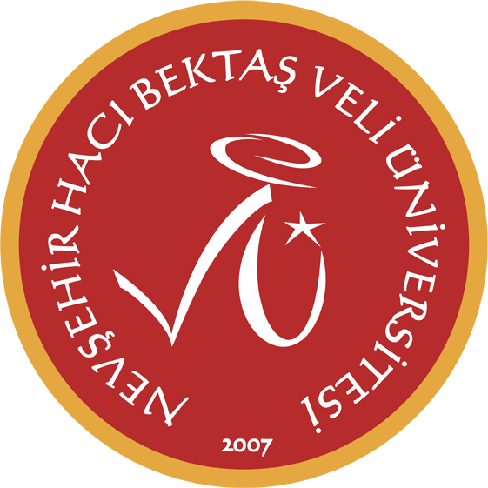
2025 - 2026 Bahar Dönemi
Fatma Başarır

 | Pazartesi | Sali | Carsamba | Persembe | Cuma
08:30 09:15
09:30 10:15 | MC – MAIN COURSE (IR A)  YDYO 9 | MC – MAIN COURSE (IR B)  YDYO 10 |  | MC – MAIN COURSE (IR B)  YDYO 10 | MC – MAIN COURSE (IR A)  YDYO 9
10:30 11:15 | MC – MAIN COURSE (IR A)  YDYO 9 | MC – MAIN COURSE (IR B)  YDYO 10 |  | MC – MAIN COURSE (IR B)  YDYO 10 | MC – MAIN COURSE (IR A)  YDYO 9
11:30 12:15 | MC – MAIN COURSE (IR A)  YDYO 9 | MC – MAIN COURSE (IR B)  YDYO 10 |  | MC – MAIN COURSE (IR B)  YDYO 10 | MC – MAIN COURSE (IR A)  YDYO 9
12:30 13:30
13:30 14:15
14:30 15:15
15:30 16:15
16:30 17:15
17:30 18:15

